# VISVESVARAYA TECHNOLOGICAL UNIVERSITY



**BELAGAVI – 590018, Karnataka**

**INTERNSHIP REPORT**

ON

**“Template-Online portfolio(resume) creator website”**

***Submitted in partial fulfilment for the award of degree(18CSI85)***

## BACHELOR OF ENGINEERING IN

## INFORMATION SCIENCE & ENGINEERING

## *Submitted by:*

**NAME : PARIKSHITH M**

**USN : 4VV19IS064**



## 

Conducted at

**Varcons Technologies Pvt Ltd**

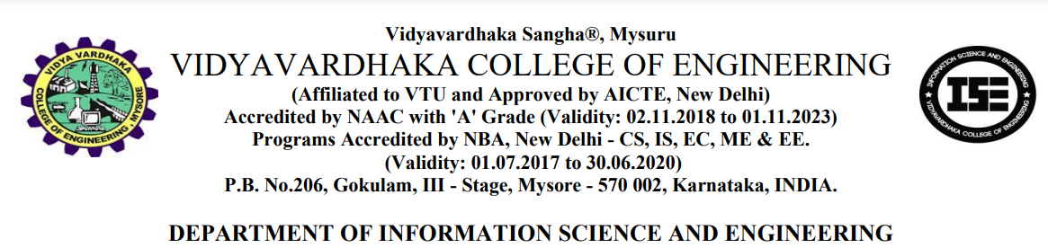



**CERTIFICATE**

This is to certify that the Internship titled **“Template-Online portfolio(resume) creator website”** carried out by **Mr.PARIKSHITH M** a bonafide student of, in partial fulfillment for the award of **Bachelor of Engineering**, in under Visvesvaraya Technological University, Belagavi, during the year 2022-2023. It is certified that all corrections/suggestions indicated have been incorporated in the report.

The project report has been approved as it satisfies the academic requirements in respect of Internship prescribed for the course Internship / Professional Practice (18CSI85)

#### Signature of Guide Signature of HOD Signature of Principal

**External Viva:**

Name of the Examiner Signature with Date

1)

2)

# D E C L A R A T I O N

I, , final year student of, VVCE MYSORE - 570002, declare that the Internship has been successfully completed, in **Varcons Technologies Pvt Ltd**. This report is submitted in partial fulfillment of the requirements for award of Bachelor Degree in Branch name, during the academic year 2022-2023.

Date: 16/03/2023 :

Place: MYSORE

USN: 4VV19IS064

NAME: PARIKSHITH M

**OFFER LETTER PROVIDED BY THE COMPANY**

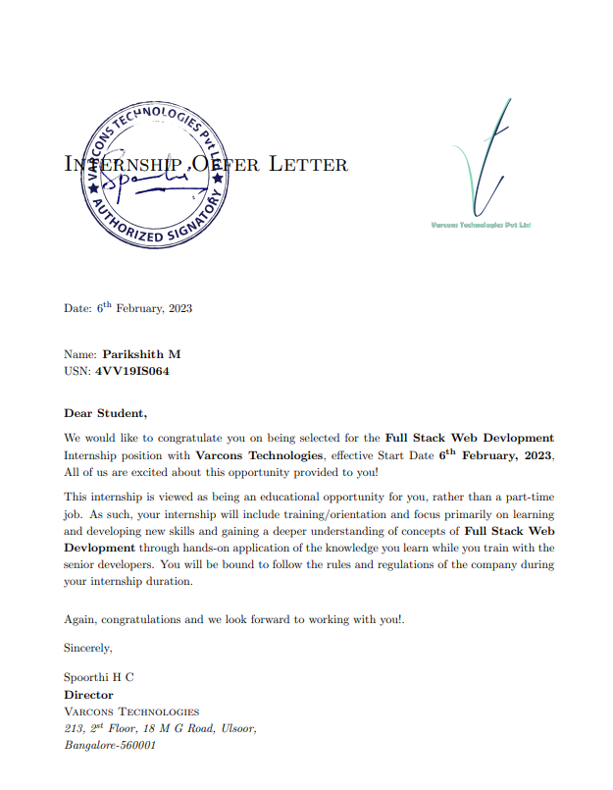

# A C K N O W L E D G E M E N T

This Internship is a result of accumulated guidance, direction and support of several important persons. We take this opportunity to express our gratitude to all who have helped us to complete the Internship.

We express our sincere thanks to our Principal**, Dr. Dr. B Sadashive Gowda** for providing us adequate facilities to undertake this Internship.

We would like to thank our Head of Dept –**Dr.** A B Rajendra Head of Department, and Engineering, for providing us an opportunity to carry out Internship and for his valuable guidance and support.

We would like to thank our **LOKNATH** Software Services for guiding us during the period of internship.

We express our deep and profound gratitude to our guide Md **Muddasir**, Associate Professor, Department, Internship Coordinator **Prof.Megha** Assistant Professor, Department for her keen interest and encouragement at every step in completing the Internship.

We would like to thank all the faculty members of our department for the support extended during Internship.

We would like to thank the non-teaching members of our dept, for helping us during the Internship.

Last but not the least, we would like to thank our parents and friends without whose constant help, the completion of Internship would have not been possible.

NAME: PARIKSHITH M

USN: 4VV19IS064

# ABSTRACT

The “Template-Online portfolio(resume) creator website” project aims to develop a web-based application that enables users to create professional-looking online portfolios and resumes using pre-designed templates. The website will provide a user-friendly interface where users can easily customize their portfolios with their personal information, education, work experience, skills, projects, and achievements. The project will leverage modern web technologies such as HTML, CSS, JavaScript, and Bootstrap to provide a responsive and visually appealing user experience. The project seeks to address the need for a simple and efficient way to create and showcase one's portfolio online, which is becoming increasingly important in today's digital world.

Additionally, the website will include a feedback mechanism to enable users to provide suggestions and report any issues they encounter while using the application. Overall, the "Template-Online portfolio(resume) creator website" project seeks to provide a convenient and user-friendly platform that enables individuals to create and showcase their professional achievements to potential employers or clients

**Table of Contents**

|  |  |  |
| --- | --- | --- |
| **Sl no** | **Description** | **Page no** |
| 1 | Company Profile | 8 |
| 2 | About the Company | 10 |
| [3](https://1.bp.blogspot.com/-dODuK8N5h1Q/Wlnyb3V9HFI/AAAAAAAACL4/WxQtCJ1pM5wccDABg4wIrTBUB0vlikXQQCLcBGAs/s1600/poly1.jpg) | Introduction | 14 |
| [4](https://1.bp.blogspot.com/-dODuK8N5h1Q/Wlnyb3V9HFI/AAAAAAAACL4/WxQtCJ1pM5wccDABg4wIrTBUB0vlikXQQCLcBGAs/s1600/poly1.jpg) | System Analysis | 17 |
| [5](https://1.bp.blogspot.com/-dODuK8N5h1Q/Wlnyb3V9HFI/AAAAAAAACL4/WxQtCJ1pM5wccDABg4wIrTBUB0vlikXQQCLcBGAs/s1600/poly1.jpg) | Requirement Analysis | 20 |
| 6 | Design [Analysis](https://4.bp.blogspot.com/-IOOxgPaXMVc/Wlj3LWvcnjI/AAAAAAAACKE/UeTFYvAxDmUDel5UBjdifeWaApB3-dXVgCLcBGAs/s1600/img1.jpg) | 22 |
| 7 | [Implementation](https://4.bp.blogspot.com/-IOOxgPaXMVc/Wlj3LWvcnjI/AAAAAAAACKE/UeTFYvAxDmUDel5UBjdifeWaApB3-dXVgCLcBGAs/s1600/img1.jpg) | 24 |
| 8 | Snapshots | 26 |
| 9 | Conclusion | 30 |
| 10 | References | 32 |

[**CHAPTER**](https://1.bp.blogspot.com/-dODuK8N5h1Q/Wlnyb3V9HFI/AAAAAAAACL4/WxQtCJ1pM5wccDABg4wIrTBUB0vlikXQQCLcBGAs/s1600/poly1.jpg) **1** **COMPANY PROFILE**

# COMPANY PROFILE

## A Brief History of Varcons Technologies Pvt Ltd

Varcons Technologies Pvt Ltd, was incorporated with a goal” To provide high quality and optimal Technological Solutions to business requirements of our clients”. Every business is a different and has a unique business model and so are the technological requirements. They understand this and hence the solutions provided to these requirements are different as well. They focus on clients requirements and provide them with tailor made technological solutions. They also understand that Reach of their Product to its targeted market or the automation of the existing process into e-client and simple process are the key features that our clients desire from Technological Solution they are looking for and these are the features that we focus on while designing the solutions for their clients.

Sarvamoola Software Services. is a Technology Organization providing solutions for all web design and development, MYSQL, PYTHON Programming, HTML, CSS, ASP.NET and LINQ. Meeting the ever increasing automation requirements, Sarvamoola Software Services. specialize in ERP, Connectivity, SEO Services, Conference Management, effective web promotion and tailor-made software products, designing solutions best suiting clients requirements.

Varcons Technologies Pvt Ltd, strive to be the front runner in creativity and innovation in software development through their well-researched expertise and establish it as an out of the box software development company in Bangalore, India. As a software development company, they translate this software development expertise into value for their customers through their professional solutions.

They understand that the best desired output can be achieved only by understanding the clients demand better. Varcons Technologies Pvt Ltd work with their clients and help them to defiine their exact solution requirement. Sometimes even they wonder that they have completely redefined their solution or new application requirement during the brainstorming session, and here they position themselves as an IT solutions consulting group comprising of high caliber consultants.

They believe that Technology when used properly can help any business to scale and achieve new heights of success. It helps Improve its efficiency, profitability, reliability; to put it in one sentence” Technology helps you to Delight your Customers” and that is what we want to achieve.

# [CHAPTER](https://1.bp.blogspot.com/-dODuK8N5h1Q/Wlnyb3V9HFI/AAAAAAAACL4/WxQtCJ1pM5wccDABg4wIrTBUB0vlikXQQCLcBGAs/s1600/poly1.jpg) 2 ABOUT THE COMPANY

1. **ABOUT THE COMPANY**

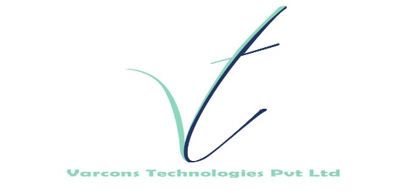

Varcons Technologies Pvt Ltd is a Technology Organization providing solutions for all web design and development, MYSQL, PYTHON Programming, HTML, CSS, ASP.NET and LINQ. Meeting the ever increasing automation requirements, Varcons Technologies Pvt Ltd specialize in ERP, Connectivity, SEO Services, Conference Management, effective web promotion and tailor-made software products, designing solutions best suiting clients requirements. The organization where they have a right mix of professionals as a stakeholders to help us serve our clients with best of our capability and with at par industry standards. They have young, enthusiastic, passionate and creative Professionals to develop technological innovations in the field of Mobile technologies, Web applications as well as Business and Enterprise solution. Motto of our organization is to “Collaborate with our clients to provide them with best Technological solution hence creating Good Present and Better Future for our client which will bring a cascading a positive effect in their business shape as well”. Providing a Complete suite of technical solutions is not just our tag line, it is Our Vision for Our Clients and for Us, We strive hard to achieve it.

## Products of Varcons Technologies Pvt Ltd.

**Android Apps**

It is the process by which new applications are created for devices running the Android operating system. Applications are usually developed in Java (and/or Kotlin; or other such option) programming language using the Android software development kit (SDK), but other development environments are also available, some such as Kotlin support the exact same Android APIs (and bytecode), while others such as Go have restricted API access.

The Android software development kit includes a comprehensive set of development tools. These include a debugger, libraries, a handset emulator based on QEMU, documentation, sample code, and zutorials. Currently supported development platforms include computers running Linux (any modern desktop Linux distribution), Mac OS X 10.5.8 or later, and Windows 7 or later. As of March 2015, the SDK is not available on Android itself, but softwaredevelopment is possible by using specialized Android applications.

**Web Application**

It is a client–server computer program in which the client (including the user interface and client- side logic) runs in a web browser. Common web applications include web mail, online

retail sales, online auctions, wikis, instant messaging services and many other functions. web applications use web documents written in a standard format such as HTML and JavaScript,which are supported by a variety of web browsers. Web applications can be considered as a specifific variant of client–server software where the client software is downloaded to the client machine when visiting the relevant web page, using standard procedures such as HTTP. The Client web software updates may happen each time the web page is visited. During the session, the web browser interprets and displays the pages, and acts as the universal client for any web application. The use of web application frameworks can often reduce the number of errors in a program, both by making the code simpler, and by allowing one team to concentrate on the framework while another focuses on a specifified use case. In applications which are exposed to constant hacking attempts on the Internet, security- related problems can be caused by errors in the program.

Frameworks can also promote the use of best practices such as GET after POST. There are some who view a web application as a two-tier architecture. This can be a “smart” client that performs all the work and queries a “dumb” server, or a “dumb” client that relies on a “smart” server. The client would handle the presentation tier, the server would have the database (storage tier), and the business logic (application tier) would be on one of them or on both. While this increases the scalability of the applications and separates the display and the database, it still doesn‟t allow for true specialization of layers, so most applications will outgrow this model. An emerging strategy for application software companies is to provide web access to software previously distributed as local applications. Depending on the type of application, it may require the development of an entirely different browser-based interface, or merely adapting an existing application to use different presentation technology. These programs allow the user to pay a monthly or yearly fee for use of a software application without having to install it on a local hard drive. A company which follows this strategy is known as an application service provider (ASP), and ASPs are currently receiving much attention in the software industry.

Security breaches on these kinds of applications are a major concern because it can involve both enterprise information and private customer data. Protecting these assets is an important part of any web application and there are some key operational areas that must be included in the development process. This includes processes for authentication, authorization, asset handling, input, and logging and auditing. Building security into the applications from the beginning can be more effective and less disruptive in the long run.

**Web design**

It is encompasses many different skills and disciplines in the production and maintenance of websites. The different areas of web design include web graphic design; interface design; authoring, including standardized code and proprietary software; user experience design; and

search engine optimization. The term web design is normally used to describe the design process relating to the front-end (client side) design of a website including writing mark up. Web design partially overlaps web engineering in the broader scope of web development. Web designers are expected to have an awareness of usability and if their role involves creating mark up then they are also expected to be up to date with web accessibility guidelines. Web design partially overlaps web engineering in the broader scope of web development.

## Departments and services offered

Varcons Technologies Pvt Ltd plays an essential role as an institute, the level of education, development of student’s skills are based on their trainers. If you do not have a good mentor then you may lag in many things from others and that is why we at Varcons Technologies Pvt Ltd gives you the facility of skilled employees so that you do not feel unsecured about the academics. Personality development and academic status are some of those things which lie on mentor’s hands. If you are trained well then you can do well in your future and knowing its importance of Varcons Technologies Pvt Ltd always tries to give you the best.

They have a great team of skilled mentors who are always ready to direct their trainees in the best possible way they can and to ensure the skills of mentors we held many skill development programs as well so that each and every mentor can develop their own skills with the demands of the companies so that they can prepare a complete packaged trainee.

## Services provided by Varcons Technologies Pvt Ltd.

* Core Java and Advanced Java
* Web services and development
* Dot Net Framework
* Python
* Selenium Testing
* Conference / Event Management Service
* Academic Project Guidance
* On The Job Training
* Software Training

# [CHAPTER](https://1.bp.blogspot.com/-dODuK8N5h1Q/Wlnyb3V9HFI/AAAAAAAACL4/WxQtCJ1pM5wccDABg4wIrTBUB0vlikXQQCLcBGAs/s1600/poly1.jpg) 3 INTRODUCTION

1. **INTRODUCTION**

## Introduction to Web Apps

Web applications are similar to the traditional applications you’d install on your Information, such as Microsoft Office. They are able to perform the same kinds of tasks, they look the same and they feel the same but there is one key difference - the application itself is not installed on your phone or Information, but lives in the cloud. Web apps are not new, but it used to be that they were often unable to compete with more traditional applications for business critical functions or where rich user interaction was required. This is no longer the case. With the power of modern web technologies, we are able to design and build performing, secure, and feature rich applications that live in the cloud and bring with them a huge number of benefits.

#### They can be accessed from anywhere.

* Because web applications are built with web technologies and they run in a web browser Internet Explorer, Google Chrome, Mozilla Firefox – this allows them to be accessed from every web enabled tool. As long as you have an internet connection you can use them.
* It allows for remote working, it allows for rapid publishing of content, it allows for real time collaboration between teams. If you have web access, you have the ability to access your business tools.

#### They are cost effective.

* Web applications are cheaper to produce and maintain than traditional applications. No matter how many platforms your business uses (Mac, Linux, Windows) web application build can be used across them all.

#### They benefit from more rapid update cycles.

* A huge benefit of web applications is that when an update is released, all of your users are immediately using that version. This doesn’t happen with installed applications, especially in large organizations with IT policies that restrict administrator access.

#### They are secure.

* Web developers have had to become experts in security – the web is a platform designed to share everything with everyone! As such, the types and levels of security included in web applications are often far greater than those seen in traditional applications.
* They also benefit from the ability to launch updates in real-time – the application on the servers is the application people are using. The applications on people’s laptops however is the version last installed. And when those laptops get left on a train it’s not a concern, as nothing is stored locally.

#### They enable more computing with fewer Information.

* Web applications push all of the hard work to the servers, and act as intermediaries between the user interface and the calculations happening behind the scenes. This means you can accomplish terrifyingly complex work on a tablet, or your phone.
* We’ve built web applications that allow people to understand the complex relationships between 250,000 pieces of art on their phones, and applications that run the business systems of one of the largest solar energy providers in the world. Often these products are not financially viable to build using traditional application processes.

## Problem Statement

Develop an application which facilitates creation of web pages having a need to install any HTML editor based software and also which can be used by any novice user (no HTML knowledge needed) that is developing web pages on the online. This module is designed to reduce the process involved in managing the activity of customers and business where the business can sell their services and the customers can buy those.

## Introduction to B2C Ecommerce Website Development with Admin Panel

B2C E-commerce website content providers to focus on creating effective assessment questions and focusing on providing a platform for easy access between Buyer and Consumer.

Here we present techniques that are pertinent to the elements of assessment process: answers submission, Informationized grading, and feedback after submission. As the modern organizations are automated and Informations are working as per the instructions, it becomes essential for the coordination of human beings, commodity and Informations in a modern

organization.

# [CHAPTER](https://1.bp.blogspot.com/-dODuK8N5h1Q/Wlnyb3V9HFI/AAAAAAAACL4/WxQtCJ1pM5wccDABg4wIrTBUB0vlikXQQCLcBGAs/s1600/poly1.jpg) 4 SYSTEM ANALYSIS

**4. SYSTEM ANALYSIS**

## Existing System

There are several existing systems, such as online portfolio builders and resume builders, that allow users to create and showcase their professional achievements. These existing systems may have varying levels of functionality, user-friendliness, and customization options. Some systems may require users to have design skills or experience, while others may provide pre-designed templates and drag-and-drop interfaces for easy customization. The existing systems may have different pricing models, with some offering free services with limited features, and others offering premium services with more advanced features. Some systems may also have limitations in terms of privacy and security, with potential risks of data breaches or hacking. Overall, the existing systems for online portfolio and resume creation have their advantages and disadvantages, and the "Template-Online portfolio(resume) creator website" project aims to provide a more efficient, user-friendly, and secure alternative for individuals looking to create and showcase their professional achievements.

## Proposed System

The proposed system for the "Template-Online portfolio(resume) creator website" project will be a web-based application that allows users to create professional-looking online portfolios and resumes using pre-designed templates. The system will provide a user-friendly interface where users can easily customize their portfolios with their personal information, education, work experience, skills, projects, and achievements. The system will leverage modern web technologies such as HTML, CSS, JavaScript, and Bootstrap to provide a responsive and visually appealing user experience.

The proposed system will have several key features, including a registration system that allows users to create their accounts, where they can save their progress and access their portfolios at any time. Users will also have the option to share their portfolios with others via social media or email. The system will prioritize user privacy and security by implementing password protection and encryption techniques to protect users' personal information.

The system's structure will follow the client-server architecture, where the client (user) interacts with the server (website) to create and store their portfolios. The website's front-end will be developed using HTML, CSS, JavaScript, and Bootstrap to provide a responsive and visually appealing user interface. The back-end will be developed using a programming language such as Python or PHP and a database management system like MySQL or PostgreSQL to store users' data securely.

The system's behavior will be modeled using use cases, which describe how users interact with the system to achieve their goals. Use cases include creating an account, customizing a portfolio, saving progress, sharing a portfolio, and providing feedback. The system must handle various user inputs and interactions, such as validating user data, displaying portfolio templates, and allowing users to preview and edit their portfolios.

Finally, the system's performance will be evaluated based on several factors, including response time, scalability, and availability. The website must respond quickly to user requests and provide a seamless user experience. The system should be scalable to handle a large number of users and portfolios. The system must be available to users 24/7, with minimal downtime for maintenance or upgrades.

Overall, the proposed system for the "Template-Online portfolio(resume) creator website" project aims to provide a convenient and user-friendly platform that enables individuals to create and showcase their professional achievements to potential employers or clients. The system will prioritize user privacy and security while providing a seamless user experience and responsive performanc

## Objective of the System

The objective of the "Template-Online portfolio(resume) creator website" project is to provide a user-friendly, efficient, and secure web-based application that enables individuals to create and showcase their professional achievements through online portfolios and resumes. The system aims to provide a convenient and accessible platform for users to showcase their skills, education, work experience, projects, and achievements to potential employers or clients.

The system's primary objective is to simplify the process of creating professional-looking online portfolios and resumes by providing pre-designed templates and easy-to-use customization tools. The system aims to eliminate the need for users to have design skills or experience by offering a user-friendly interface and intuitive features.

Another objective of the system is to prioritize user privacy and security by implementing password protection and encryption techniques to protect users' personal information. The system aims to provide a secure platform for users to store and share their portfolios with others.

The system's other objectives include providing a responsive and visually appealing user interface, allowing users to save their progress and access their portfolios at any time, and enabling users to share their portfolios with others via social media or email.

# [CHAPTER](https://1.bp.blogspot.com/-dODuK8N5h1Q/Wlnyb3V9HFI/AAAAAAAACL4/WxQtCJ1pM5wccDABg4wIrTBUB0vlikXQQCLcBGAs/s1600/poly1.jpg) 5 REQUIREMENT ANALYSIS

**5. REQUIREMENT ANALYSIS**

## Hardware Requirement Specification

* + MySQL
  + NODE JS
  + Notepad++ Editor
  + Processor: Intel core i5 processer
  + Memory: 15.6 GB
  + Hard Disk: 40 GB

## Software Requirement Specification

### Functional Requirements

* + Responsive design
  + User feedback
  + Search functionality
  + Portfolio preview and editing

### Non-Functional Requirements

#### Availability

The online registration system shall permit backing up of the registration database while other registration actives are going on.

#### Accessibility

The system shall be accessible by people with specific vision needs to the extent that a user shall be able to display whole user interface in a larger font without truncating displayed text or other values.

#### Security

The access permissions for system data may only be change by the systems data administrator passwords shall never be viewable at the point of entry or any other time.

# [CHAPTER](https://1.bp.blogspot.com/-dODuK8N5h1Q/Wlnyb3V9HFI/AAAAAAAACL4/WxQtCJ1pM5wccDABg4wIrTBUB0vlikXQQCLcBGAs/s1600/poly1.jpg) 6 DESIGN ANALYSIS

1. **DESIGN & ANALYSIS**

Design & analysis for the "Template-Online portfolio(resume) creator website" project involves creating a detailed plan for the system's development and analysing its technical requirements. Here are some key aspects of the design and analysis process:

1. System architecture: The system architecture is the backbone of the project, and it determines how different components of the system interact with each other. The system should be designed to ensure scalability, modularity, and maintainability. The architecture should consist of the user interface, database, server, and third-party integrations.
2. User interface design: The user interface design should be intuitive and easy to use. The design should prioritize user experience, ensuring that users can easily customize their portfolios, preview their work, and share their portfolios. The interface should be responsive, allowing users to access the system on different devices.
3. Database design: The database should be designed to store user information securely, including personal information, education, work experience, projects, and achievements. The database should be scalable, ensuring that it can handle an increasing number of users.
4. Third-party integrations: The system should integrate with third-party tools, such as social media and email, to enable users to share their portfolios easily. The system should also be compatible with different web browsers and devices.
5. Security analysis: Security is critical for any web-based application, and the system should be designed with security in mind. The system should implement measures such as password protection and encryption techniques to protect users' personal information.
6. Performance analysis: The system's performance should be analysed to ensure that it can handle many users and maintain fast response times. The system should be optimized for speed and should be able to handle high traffic loads.
7. Testing and quality assurance: The system should undergo extensive testing to ensure that it functions as expected and meets user requirements. Quality assurance measures should be implemented to ensure that the system meets high standards of quality.

Overall, the design & analysis process for the "Template-Online portfolio(resume) creator website" project aims to ensure that the system is designed to meet user requirements, is secure, scalable, and performs optimally. It involves careful planning and analysis to ensure that the system is efficient, user-friendly, and meets the highest standards of quality.

# [CHAPTE](https://1.bp.blogspot.com/-dODuK8N5h1Q/Wlnyb3V9HFI/AAAAAAAACL4/WxQtCJ1pM5wccDABg4wIrTBUB0vlikXQQCLcBGAs/s1600/poly1.jpg)R 7 IMPLEMENTATION

1. **IMPLEMENTATION**

The implementation of the "Template-Online portfolio(resume) creator website" project involves developing the system based on the design and analysis process. Here are some key steps involved in implementing the project:

1. Setting up the development environment: The development environment should be set up to ensure that the project's requirements are met. This includes selecting the programming language, web server, database management system, and development tools.
2. Front-end development: The front-end of the system involves designing and implementing the user interface. The user interface should be user-friendly, intuitive, and responsive. It should allow users to customize their portfolios easily, preview their work, and share their portfolios.
3. Back-end development: The back-end of the system involves implementing the functionality of the system, including user authentication, database management, and third-party integrations. The back-end should be scalable, secure, and optimized for performance.
4. Testing and quality assurance: The system should undergo extensive testing to ensure that it functions as expected and meets user requirements. Quality assurance measures should be implemented to ensure that the system meets high standards of quality.
5. Deployment: Once the system has been thoroughly tested, it can be deployed to a production environment. This involves configuring the web server, database, and other components of the system.
6. Maintenance and support: After deployment, the system requires ongoing maintenance and support. This includes fixing bugs, updating software components, and providing customer support to users.

Overall, the implementation of the "Template-Online portfolio(resume) creator website" project requires careful planning, design, and development. It should be implemented using best practices in software development, including agile development, version control, and continuous integration and deployment. By following these best practices, the system can be developed efficiently, reliably, and with high quality

# [CHAPTE](https://1.bp.blogspot.com/-dODuK8N5h1Q/Wlnyb3V9HFI/AAAAAAAACL4/WxQtCJ1pM5wccDABg4wIrTBUB0vlikXQQCLcBGAs/s1600/poly1.jpg)R 8 SNAPSHOTS

* 1. **SNAPSHOTS**

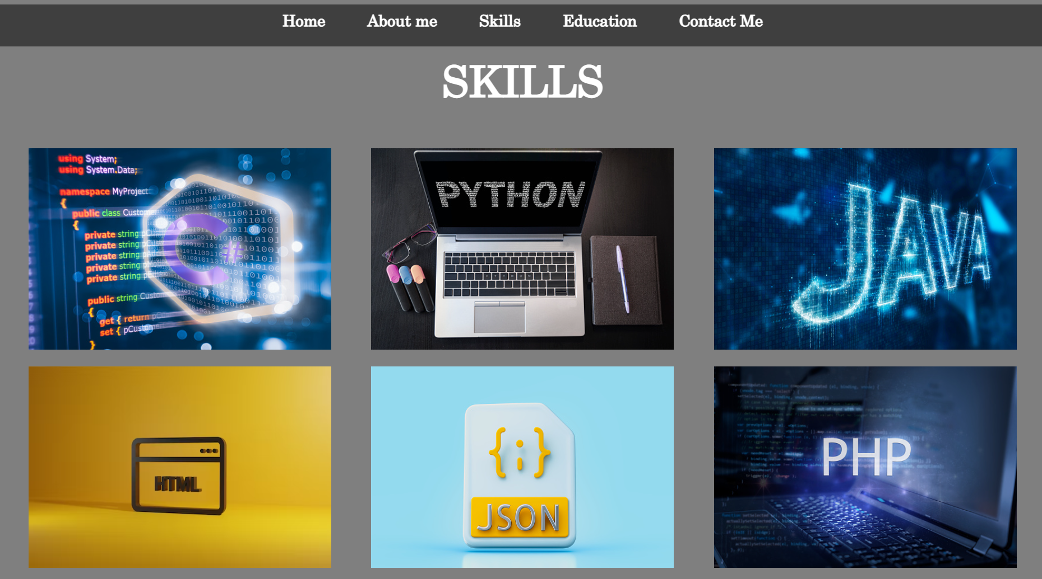

**Figure 1 Skills**

# [CHAPTE](https://1.bp.blogspot.com/-dODuK8N5h1Q/Wlnyb3V9HFI/AAAAAAAACL4/WxQtCJ1pM5wccDABg4wIrTBUB0vlikXQQCLcBGAs/s1600/poly1.jpg)R 9 CONCLUTION

* 1. **CONCLUTION**

In conclusion, the "Template-Online portfolio(resume) creator website" project is a web-based application that allows individuals to create and showcase their professional achievements in an easy-to-use and customizable portfolio. The project's objective is to provide a user-friendly, efficient, and secure platform for individuals to create and showcase their professional achievements to potential employers or clients.

The system's functional requirements include a registration system, portfolio customization, portfolio sharing, password protection, and encryption, user feedback, portfolio preview and editing, user notification, responsive design, search functionality, and help and support.

* The design & analysis process involves creating a detailed plan for the system's development and analysing its technical requirements, including system architecture, user interface design, database design, third-party integrations, security analysis, performance analysis, testing, and quality assurance.

Overall, the "Template-Online portfolio(resume) creator website" project provides an excellent opportunity for individuals to create a professional portfolio that showcases their skills, education, work experience, projects, and achievements. The project's user-friendly design and customization options make it easy for users to create and share their portfolios, while the system's security and scalability ensure that users' personal information is protected.

# REFERENCE

* [http://www.google.com/](http://www.google.com)
* <http://www.gihub.com>
* <http://www.figma.com>
* <http://www.unplash.com>